The Title Should be 14-point Times New Roman, Boldface, Centered: Please Follow the Capitalization Rules of APA 7th Edition (Capitalize All Words of Four Letters or More)

Author name
Affiliation

Abstract
Write an abstract of no more than 200 words to provide readers with an overview of the research. In this section, the background, methods, results, and conclusion should be described concisely, though not all articles have to follow this particular structure. Use 12-point font overall.
An extra spacing AFTER the Keywords section.
Keywords: no, more, than, five words, word or phrase
Do NOT write INTRODUCTION as a heading.
Automatically indent five spaces at the beginning of a paragraph. All submissions must conform to the requirements of the Publication Manual of the American Psychological Association, 7th edition.
In the introduction section, you need to state the purpose or motivation of the study, often with reference to previous studies. ………………………………
Indenting:
Start writing the paragraphs 5 letters to the right throughout the paper
……………………………………………………………………………………….. ……….…………………………………………………………………………………… .………………………………………………………… It is important to describe the research background, review previous studies, define key terms, and state the importance of your research.
There should be No extra spacing between paragraphs (Before headings).

Literature Review (or an Appropriate Subtitle)
………………………………………………………………………………..……… .…………………………………………………………………………………….……. .………………………………………………………………………… (A***, 2014; B** & *******, 2018). ……………………
…… …………………………………………… (A***, 2014; B****, 2016; C** & *******, 2018).
Level 1 heading
Method
In the method section, you need to describe where, when, and how the study was conducted so that potential readers can replicate the study if necessary. Also include a Notes section before the reference section if needed.
Materials and Procedure
Level 2 heading
Materials used in this study included two different kinds of speaking tasks and a questionnaire . . .
Level 3 heading
Speaking Tasks
Two sets of tasks were prepared. . …… …… …… …… …… …… …… …… …… …… …… …… …… …… …… …… …… …… …… …… …… …… …… …… …… …… …… …… …… …… …… …… …… …… …… …… …… …… …… …… …… …… …… …… …… …… …… …… …… …… …… …… ……
Level 4 heading
Questionnaire with Multiple Questions. A questionnaire, which consisted of six multiple-choice questions and . . , was also used in this study.. …… …… …… …… …… …… …… …… …… …… …… …… …… …… …… …… …… …… …… …… …… …… …… …… …… …… …… …… …… …… …… …… …… …… …… ……
Evaluating Scores. In addition to questionnaire results………………………………………………………………………………………………………………………………………………….
Level 5 heading
Results
In the results section, outcomes of the study must be written clearly. Only the facts should be described here; opinions and induction must be placed in the discussion section, though it is possible to combine these two sections when necessary. Tables and figures should be fully utilized to make the outcomes visually accessible to the readers.
← An extra spacing before and after Tables & Figures
Table 1
If the p value is very low, write p < .001, not p = .000.
Descriptive Statistics for the Speaking Tests
 | Pre-test |  |  | Post-test
Group | n | M (SD) |  | n | M (SD)
Group 1 | 30 | 50.56 (12.31) |  | 29 | 60.82 (15.31)
Group 2 | 28 | 48.22 (11.62) |  | 28 | 51.75 (11.89)
Note. Student evaluations of testing were administered in two modalities.
← An extra spacing before and after Tables & Figures
Figure 1
Do not use vertical borders to separate data & Do not use borders around every cell in a table.
Average Study Time During 2014 Spring Semester
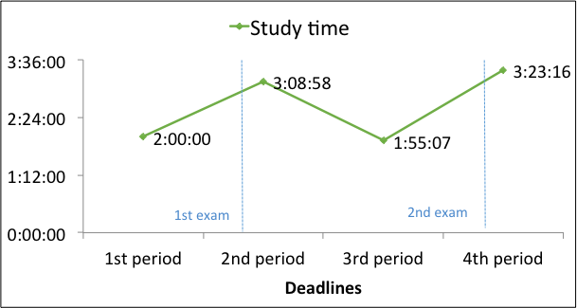
Note. Figure captions should be below the figures. Adapted from “Title of Article,” by A. A.
← An extra spacing before and after Tables & Figures
Using figures and/or tables, you need to number them consecutively and refer to all of them in the text. Make tables in the Word document. Do not take screen shots from elsewhere and add them to your paper.
You need to obtain permission to reproduce any material such as figures and tables for which you do not own the copyright, and for ensuring that the appropriate acknowledgements are included in your manuscript as described above.
Discussion
In the discussion section, it is necessary to rationally argue your points based on the obtained results. You can describe limitations of the study if necessary.
Conclusion
In the conclusion section, important findings should be summarized briefly. You can add implications from your study or expectations of further studies. …… …… …… …… …… …… …… …… …… …… …… …… …… …… …… …… …… …… …… …… …… …… …… …… …… …… …… …… …… …… …… …… …… …… …… …… …… …… …… …… …… …… …… …… …… …… ……
References
American Psychological Association. (2020). American Psychological Association strategic plan. https://www.apa.org/about/apa/strategic-plan
Put an automatic indent of five spaces (5 letters).
Beach, R. (1986). Showing students how to assess: Demonstrating techniques for response in the writing conference. College Composition and Communication, 37(1), 56–65. https://doi.org/10.2307/357382
journal article reference with DOI
Berk, R. A. (2012). Top 20 strategies to increase the online response rates of student rating scales. International Journal of Technology in Teaching and Learning, 8(2), 98–107.
journal article reference without DOI or URL
Clark, K. R., & Buckley, M. B. (2017). Using a synthesis matrix to plan a literature review. Radiologic Technology, 88(3), 354–357. http://www.radiologictechnology.org/content/88/3/354.extract
journal article reference without DOI
journal article reference without DOI
Dunn, D. S., & Smith, R. A. (2008). Writing as critical thinking. In D. S. Dunn, J. S. Halonen, & R. A. Smith (Eds.), Teaching critical thinking in psychology: A handbook of best practices (pp. 163–173). Blackwell Publishing. https://doi.org/10.1002/9781444305173.ch14
book chapter reference
Ferris, D. R. (2003). Response to student writing: Implications for second language students. Routledge. https://doi.org/10.4324/9781410607201
book reference

Appendices
Appendix A: The Title of Appendix A
Add an appendix [appendices] section if necessary.

Appendix B: The Title of Appendix B

