The Title Should be 14-point Times New Roman, Boldface, Centered: Please Follow the Capitalization Rules of APA 6th Edition (Capitalize All Words of Four Letters or More)

Abstract
Write an abstract of no more than 200 words to provide readers with an overview of the research. In this section, the background, methods, results, and conclusion should be described concisely, though not all articles have to follow this particular structure. Use 12-point font overall except for the title of the paper.

Keywords: no, more, than, five words, word or phrase

Introduction
Indent with five spaces at the beginning of a paragraph. All submissions must conform to the requirements of the Publication Manual of the American Psychological Association, 6th edition.
In the introduction section, you need to state the purpose or motivation of the study, often with reference to previous studies. ………………………………
……………………………………………… .…………………………………………………………………………………… .………………………………………………………………………………………………… .………………………………………………………………………………………………… .………………………………………………………
… It is important to describe the research background, review previous studies, define key terms, and state the importance of your research.

Literature Review
……………………………………………… .…………………………………………………………………………………… .………………………………………………………………………… (****, 2014; *** & *******, 2018). ……………………
…………………… .………………………………………………………………………… (****, 2014; *****, 2016; *** & *******, 2018).

Method
In the method section, you need to describe where, when, and how the study was conducted so that potential readers can replicate the study if necessary. Also include a footnotes section¹ after the reference section.

Materials and Procedure
Materials used in this study included two different kinds of speaking tasks and a questionnaire . . .
Speaking tasks. Two sets of tasks were prepared. . …… …… …… …… …… …… …… …… …… …… …… …… …… …… …… …… …… …… …… …… …… …… …… …… …… …… …… …… …… …… …… …… …… …… …… …… …… …… …… …… …… …… …… …… …… …… …… …… …… …… …… …… ……
Questionnaire. A questionnaire, which consisted of six multiple-choice questions and . . , was also used in this study.. …… …… …… …… …… …… …… …… …… …… …… …… …… …… …… …… …… …… …… …… …… …… …… …… …… …… …… …… …… …… …… …… …… …… …… …… …… …… …… …… …… …… …… …… …… …… …… …… …… …… …… …… …… ……
…… …… …… …… …… …… …… …… …… …… …… …… …… …… ……

Results
In the results section, outcomes of the study must be written clearly. Only the facts should be described here; opinions and induction must be placed in the discussion section, though it is possible to combine these two sections when necessary. Tables and figures should be fully utilized to make the outcomes visually accessible to the readers.

Table 1
Descriptive Statistics for the Speaking Tests
 | Pre-test |  |  | Post-test
Group | n | M (SD) |  | n | M (SD)
Group 1 | 30 | 50.56 (12.31) |  | 29 | 60.82 (15.31)
Group 2 | 28 | 48.22 (11.62) |  | 28 | 51.75 (11.89)

Using figures and/or tables, you need to number them consecutively and refer to all of them in the text.²

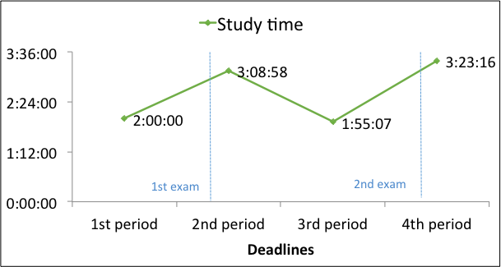
Figure 1. Average study time during 2014 spring semester. Figure captions should be below the figures. Adapted from “Title of Article,” by A. A. Author and B. B. Author, year, Title of Journal, volume, p. xx. Copyright year by the Name of Copyright Holder.

You need to obtain permission to reproduce any material such as figures and tables for which you do not own the copyright, and for ensuring that the appropriate acknowledgements are included in your manuscript as described above.

Discussion
In the discussion section, it is necessary to rationally argue your points based on the obtained results. You can describe limitations of the study if necessary.

Conclusion
In the conclusion section, important findings should be summarized briefly. You can add implications from your study or expectations of further studies. …… …… …… …… …… …… …… …… …… …… …… …… …… …… …… …… …… …… …… …… …… …… …… …… …… …… …… …… …… …… …… …… …… …… …… …… …… …… …… …… …… …… …… …… …… …… ……

References
American Psychological Association. (2010). Publication manual of the American Psychological Association (6th ed.). Washington, DC: American Psychological Association.
Put an indent with five spaces.
Benson, P. (2006). Autonomy in language teaching and learning. Language Teaching, 40, 20–40. doi:10.1017/S026144806003958
Berndt, T. J., & Savin-Williams, R. C. (1993). Peer relations and friendships. In P. H. Tolan, & B. J. Kohler (Eds.), Handbook of clinical research and practice with adolescents (pp. 203–219). Oxford, England: Wiley.
Duck, S. (Ed.). (1988). Handbook of personal relationships: Theory, research, and interventions. Chichester, UK: Wiley.
Huston, A. C., Wartella, E., Donnerstein, E., Scantlin, R., & Kotler, J. (1998). Measuring the effects of sexual content in the media: A report to the Kaiser Family Foundation. Oakland, CA: The Kaiser Family Foundation.
Karmiloff-Smith, A. (1992). Beyond modularity: A developmental perspective on cognitive science. Cambridge, MA: MIT Press.
Reis, H. T., & Shaver, P. (1988). Intimacy as an interpersonal process. In S. Duck (Ed.), Handbook of personal relationships: Theory, research, and interventions (pp. 367–389). Chichester, UK: Wiley.
Uzawa, H. (1998). Nihon no kyoiku wo kangaeru [Thinking about Japanese education]. Tokyo: Iwanami Shoten.

Notes
¹ You can add notes here if necessary.
² . . .

Appendix A: The Title of Appendix A
Add an appendix [appendices] section if necessary.

Appendix B: The Title of Appendix B

