The Title Should be 14-point Times New Roman, Boldface, Centered: Please Follow the Capitalization Rules of APA 6th Edition

Abstract
Write an abstract of no more than 200 words in order to provide readers with an overview of the research. In this abstract section, background, methods, results, and conclusion should be described concisely, though not all articles will follow this particular structure.

Keywords: no, more, than, five words

Introduction
All submissions to JACET Selected Papers must conform to the requirements of the Publication Manual of the American Psychological Association, 6th edition.
In the introduction section, state the purpose or motivation of the study, often with reference to previous studies.
It is important to describe the research background, review previous studies, define key terms, and state the importance of the research (*****, 2014).
Delete any textual references that refer to you, the author(s), and substitute with “*****” as in the citation example above.

Methods
In the methods section, describe where, when, and how the study was conducted so that potential readers can replicate the study if necessary. This section can be divided into subsections such as participants, materials, procedures, and data analyses, if that is convenient for your description.¹

Materials and Procedure
Materials used in this study included two different kinds of speaking tasks and a questionnaire . . .
Speaking tasks. Two sets of tasks were prepared . . .
Questionnaire. Further material used in this research was a questionnaire, which consisted of six multiple-choice questions and . . .

Results
In the results section, outcomes of the study must be written clearly. Only the facts should be described here; opinions and induction must be placed in the next discussion section, though it would be possible to combine these two sections when necessary. Tables and figures should be fully utilized to make the outcomes visually accessible to the readers.

Table 1
Descriptive Statistics for the Speaking Tests
 | Pre-test |  |  | Post-test
Group | n | M (SD) |  | n | M (SD)
Group 1 | 30 | 50.56 (12.31) |  | 29 | 60.82 (15.30)
Group 2 | 28 | 48.00 (11.62) |  | 28 | 51.75 (11.89)
Note. M = mean; SD = standard deviation. Table captions should be above the tables.

Concerning decimal values, “carry all comparable values to the same number of decimal places” (American Psychological Association, 2010, p. 137). Regarding JACET Selected Papers, figures and tables should be left-justified.
Figures and/or tables should be numbered consecutively and all of them should be referred to in the text.²
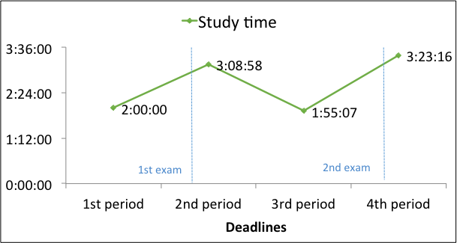
Figure 1. Average study time during 2014 spring semester. Figure captions should be below the figures. Adapted from “Title of Article,” by A. A. Author and B. B. Author, year, Title of Journal, volume, p. xx. Copyright year by the Name of Copyright Holder.

Permission must be obtained to reproduce any material such as figures and tables for which you do not own the copyright, and for ensuring that the appropriate acknowledgements are included in your manuscript as described above.

Discussion
In the discussion section, it is necessary to rationally argue your points based on the obtained results. Limitations of the study may be described if necessary.

Conclusion
In the conclusion section, important findings should be summarized briefly. Implications from your study or the expectations of further studies may be added.

Notes
¹ Notes may be added here if necessary.
² . . .

References
[List all the quoted studies in alphabetical order. The following reference examples are based on the APA 6th edition. Refer to this if you cannot find what you want to see below.]
(Authored book)
American Psychological Association. (2010). Publication manual of the American Psychological Association (6th ed.). Washington, DC: American Psychological Association.
Huston, A. C., Wartella, E., Donnerstein, E., Scantlin, R., & Kotler, J. (1998). Measuring the effects of sexual content in the media: A report to the Kaiser Family Foundation. Oakland, CA: The Kaiser Family Foundation.
Karmiloff-Smith, A. (1992). Beyond modularity: A developmental perspective on cognitive science. Cambridge, MA: MIT Press.
(Edited book)
Duck, S. (Ed.). (1988). Handbook of personal relationships: Theory, research, and interventions. Chichester, UK: Wiley.
(Journal article)
Benson, P. (2006). Autonomy in language teaching and learning. Language Teaching, 40, 20–40. doi:10.1017/S026144806003958
****. (2014). ***************************************************************.
(Chapter in an edited book)
Berndt, T. J., & Savin-Williams, R. C. (1993). Peer relations and friendships. In P. H. Tolan, & B. J. Kohler (Eds.), Handbook of clinical research and practice with adolescents (pp. 203–219). Oxford, England: Wiley.
Reis, H. T., & Shaver, P. (1988). Intimacy as an interpersonal process. In S. Duck (Ed.), Handbook of personal relationships: Theory, research, and interventions (pp. 367–389). Chichester, UK: Wiley.
(Translated work)
Uzawa, H. (1998). Nihon no kyoiku wo kangaeru [Thinking about Japanese education]. Tokyo: Iwanami Shoten.

Appendix A: The Title of Appendix A
Add an appendix [appendices] section if necessary.

Appendix B: The Title of Appendix B

